DRAFT Terms of Reference for the
Pacific Salmon Allocation Policy Review

Last Updated: October 1, 2020

In April 2018, then Minister of Fisheries and Oceans and the Canadian Coast Guard, the Honourable Dominic LeBlanc released a statement following the B.C. Supreme Court Ahousaht decision. The statement contained the following commitment – “As an immediate step, I have directed Fisheries and Oceans Canada to review the Pacific Salmon Allocation Policy. We will work in collaboration with Indigenous groups and all stakeholders to renew and co-develop this policy.” This process will be conducted in a manner that respects Canada’s nation-to-nation relationship with Indigenous peoples and engages stakeholders, and seeks to develop and build consensus for recommended policy options.

A. Terms of Reference Purpose

This Terms of Reference serves as a road map that Fisheries and Oceans Canada (DFO), First
Nations, and stakeholders will utilize to develop recommendations towards renewing the 1999
Salmon Allocation Policy (SAP). Included in this document are both the process for the review (e.g. guiding principles, engagement, workflow, phases, etc.), as well as the scope of the review (objectives of the review and topic areas that the policy review will or will not address).

The 1999 SAP sets out a series of principles for salmon allocation and priority in British Columbia among three harvest groups (First Nations’ Food, Social and Ceremonial (FSC) and treaty defined fisheries; commercial fisheries; and recreational fisheries) and within the commercial fishery among gear types (gillnet, seine and troll). This policy has guided the priority of annual domestic allocations of salmon harvested in B.C. Since the SAP was first adopted twenty years ago, there have been substantial changes in terms of fisheries management, fisheries policy, Aboriginal rights, treaties and reconciliation. There have also been increased conservation requirements for stocks of concern and Pacific salmon returns have become more uncertain and variable from year to year.

Most recently, within the 2018 BC Supreme Court Ahousaht decision, the application of the SAP
(1999) was found to be an unjustified infringement of the five Nuu-chah-nulth Nations’
(Ahousaht, Ehattesaht/ Chinekint, Hesquiaht, Mowachaht/Muchalaht, and Tla-o-qui-aht) Aboriginal rights to fish and sell fish insofar as the SAP accords priority to the recreational fishery over the Five Nations’ right-based sale fishery for Chinook and Coho salmon. To the extent that the SAP applies to the Five Nations in the manner declared an unjustifiable infringement by the Court, the SAP is of no force and effect in its application to the Five Nations’ exercise of their aboriginal right to fish and sell fish. DFO has responded to the court decision through the development of a Fisheries Management Plan for the Five Nations, which addresses the right to sell fish. Rather than designing a process limited to addressing the Court’s findings in Ahousaht, DFO has initiated a comprehensive process to review and replace the SAP (1999).

The process for replacing the SAP (1999) will entail provincial scale engagement that will reflect Canada’s nation-to-nation relationships with First Nations, and involve affected stakeholders, in a collaborative approach.

The process to replace the SAP (1999) will not in any way define or limit any Aboriginal title or rights of First Nations and will be without prejudice to the positions of any parties with respect to Aboriginal title or rights.

B. Policy Scope

- Geographic Scope

The new SAP will apply only to the allocation of salmon to be fished within the boundaries of
British Columbia. A separate Yukon Allocation Policy Renewal Process has been initiated in the Yukon, which will be responsive to differences in species, Indigenous Treaty and fishery considerations.

- Content

The new SAP will describe the main harvest groups and set out principles to define allocation priority among these harvest groups. The policy will not include allocation within sectors, as this is defined in separate policies where applicable (e.g. 1993 Policy for the Management of Aboriginal Fishing, 2015 Commercial Salmon Allocation Framework). The policy will also not include specific operational guidance or implementation measures, as these will also be included in separate documents, such as salmon Integrated Fisheries Management Plans or other management plans. This separation of policy from operational material will allow future reviews of both to occur more easily. However, basic precepts for operational and/or management guidance may be included in developing the concept of priority and its principles.

After conservation, First Nations’ priority for Food, Social and Ceremonial (FSC) and Treaty Domestic fisheries will remain the highest priority and that aspect of the 1999 Policy will not be reconsidered in the SAP review.

Policy discussions are anticipated to include topics such as, but not limited to:
  - Relative priority of allocation among the different harvest groups;
  - The meaning of priority, and, the principles of priority; and, within that, identification of basic elements and guidelines for achieving and upholding those principles in the operation and management of the fishery;
  - Inter-sectoral allocation between recreational and commercial harvesters;
  - Relative priority of asserted aboriginal rights, economic opportunity fisheries and non-treaty negotiated fisheries agreements;
  - Principles for priority, management and allocation of fish caught as by-catch, and incidental mortality;
  - Hatchery fish access;
  - Long-term SAP advisory committee; and
  - The priority of fish for scientific and management purposes (e.g. test fisheries).

The renewed SAP will also need to reflect the relative priority of First Nations rights-based sale fisheries as they are formally recognized or agreed to.

The renewed SAP will be developed so as to be consistent with existing polices and case law, while being drafted so as to not require revisions to account for other First Nations’ rights to fish that may be recognized in the future. The intent is that, once recognized, the SAP will clearly outline how these fisheries receive priority of allocation. However, negotiated agreements and court cases remain the vehicles through which First Nations’ rights-based fisheries are recognized and delineated and DFO’s obligations determined. The SAP review will not in any way define or limit any treaty or Aboriginal title or rights of First Nations and will be without prejudice to the positions of t Canada and First Nations with respect to reconciliation processes, and treaty and Aboriginal title or rights.
Throughout the SAP renewal process, it is acknowledged that interests will be raised that are related to the SAP but not within the direct scope of this SAP review such as other fisheries policies, regulations, issues and processes. Given the limited timeframe for this SAP process, discussions will need to focus on issues central to a revised SAP. Other related interests will therefore be recorded and potential venues where they could be addressed will be identified. Related issues may include: intra-sectoral allocations, operational and implementation details, compensation, mitigation and voluntary licence relinquishment, stock assessment, fishery monitoring and catch reporting, enforcement, species at risk of extinction but not legislatively protected, in-season management, localized management, co-governance, species rebuilding plans, habitat restoration, enhancement and hatchery production, predation, and climate change impacts and adaptations. Other related issues may be added upon agreement among the parties.

Developments in other concurrent policy review processes will be reflected in the SAP Review process when they touch on allocation.

C. Policy Objectives and Parameters

The following objectives will be used as guidance during the process when participants are assessing different options and considering issues of interest. To the extent possible, suggestions made for updating the SAP will need to be consistent with the principles and objectives as outlined below. These objectives will also be used to create measurable criteria in the Evaluation phase of this process.

- Conservation
  - The overarching context in which the SAP is rooted is conservation. The conservation and sustainable use of Pacific salmon is promoted through a precautionary approach to managing fisheries; priority to rebuild depressed wild salmon stocks addressing incidentally caught species; actions to maintain fish habitat and ecosystem integrity; and recognition of the need for timely and accurate fisheries catch information.
  - The policy will allow for precautionary management in its implementation. In general, the precautionary approach in fisheries management is about being cautious when scientific information is uncertain, unreliable or inadequate and not using the absence of adequate scientific information as a reason to postpone or fail to take action to avoid serious harm to the resource. This requires a recognition that the level of uncertainty and risk (e.g. arising from increased variability of salmon returns due to climate changes) will influence fisheries management allocation and management decisions. This also requires recognition that socio-economic values should not supersede conservation requirements to protect and rebuild depressed wild salmon stocks.
  - Conservation will not be compromised in the development of principles to guide salmon allocation priority.
  - Conservation is a shared responsibility.
  - The new policy will recognize that habitat protection and restoration are critical to conservation; and, the attainment of sustainable and beneficial salmon allocations and priority.

- Case Law
● The policy will be consistent with relevant case law including but not limited to
Sparrow and the court findings on priority in allocation of the right of the Five
Nations (Ahousaht, Ehattesaht/ Chinehkint, Hesquiaht, Tla-o-qui-aht,
Mowachaht/Muchalaht) as found in Ahousaht Indian Band and Nation v. Canada.

- Constitutional Requirements
● The policy will be consistent with constitutional requirements in respect of Aboriginal and Treaty rights under s.35 of the Constitution Act, 1982.

- International Obligations
● The policy will be consistent with Canada’s international obligations including the Pacific Salmon Treaty, which sets out provisions for the conservation, harvest limits and international sharing of Pacific salmon harvests between Canada and the United States, and UNDRIP.

- Departmental Responsibilities
● The federal government has constitutional responsibility for fisheries management including the conservation and protection of salmon resources. This includes responsibility for determining whether or not salmon fishing activities may be carried out and the particular rules under which they may be carried out, consistent with the Constitution (including s. 35 constitutional obligations), treaties, statutes, negotiated agreements with First Nations, and common law. The Department of Fisheries and Oceans Act provides the Minister of Fisheries and Oceans Canada with the legislative authority for the management and regulation of the fisheries, and the Fisheries Act provides a framework for the proper management and control of fisheries, and the conservation and protection of fish and fish habitat, including by preventing pollution. Fisheries management policies, including the SAP, provide guidance for fisheries managers within this legislative framework.

- Consistency with Existing Policies
    - The revised SAP will need to be consistent and/or compatible with DFO policies and frameworks, including but not limited to the Wild Salmon Policy, Sustainable Fisheries Framework, Fishery Monitoring Policy and the Selective Fishing Policy.
    - Where issues are identified with existing policies in relation to options being discussed for SAP, these issues will be raised as early in the process as possible. The goal is for the objectives of the SAP and other policies to be met in a coordinated manner and for inconsistencies to be identified and resolved, where possible.
    - Similarly, developments in other concurrent policy review processes will be reflected in the SAP Review process when they touch on salmon fishery allocation.

- Enabling
    - The SAP must provide sufficient guidance and clarity in the immediate term, while being able to adapt to changing contexts over time.
    - The policy will be drafted so as to not require revisions to account for other First Nations’ rights to fish that may be recognized in the future and to account for changing FSC needs and development of FSC policy.

- Flexibility
● End outcomes will be described, but the means by which the outcomes are achieved may not be prescribed, thereby allowing for different implementation approaches that are geographically or species appropriate, or which may evolve over time.

- Clarity
    - Terms within the policy are unambiguous.
    - The meaning of the policy is easily, commonly understood leading to consistency in interpretation.
    - The SAP will seek to provide increased predictability and transparency around allocation priorities, while recognizing that changing environmental conditions and fluctuating abundance may result in uncertainty regarding year-to-year harvest opportunities.

- Sustainable Use
    - Resource management decisions may consider biological, cultural, social, and economic consequences and reflect best science including multiple Indigenous Traditional Knowledge sources (Indigenous, local, ITK, other).
    - Goals of sustainable use include:
○ Ongoing and future sustainability of the resource;
○ Meeting obligations to First Nations for FSC, Domestic Treaty, negotiated agreements and aboriginal rights- based obligations;
○ Contributing to social well-being (e.g. food source, enjoyment), and providing employment and other economic benefits to Indigenous people, other individuals and fisheries-dependent communities;
○ Recognition of the long history of First Nations’ reliance on and sustainable use of salmon; and,
○ Maintaining the potential for future generations to meet their aspirations.⁶
● Opportunities for sustainable use are subject to meeting conservation objectives.
● With respect to Pacific salmon fisheries, selective fishing is an important component of sustainable use.

D. Process-Related Guiding Principles

1. Crown Duty to Consult
- The Government of Canada has a duty to consult, and where appropriate, accommodate Indigenous groups when it considers conduct that might adversely impact potential or established Aboriginal or treaty rights.⁷
- The Government of Canada also undertakes consultation and engagement for reasons of good governance, sound policy development and decision-making, and to strengthen relationships.
- DFO will be responsible for consulting with First Nations during the SAP review process.

- See Canada’s Policy for Conservation of Wild Pacific Salmon: https://www.pac.dfo-mpo.gc.ca/fmgp/salmon-saumon/wsp-pss/policy-politique/index-eng.html
- 2011 Updated Guidelines for Federal Officials to Fulfill the Duty to Consult (https://www.aadncaandc.gc.ca/DAM/DAM-INTER-HQ/STAGING/texte-text/intgui_1100100014665_eng.pdf
  - Application of UNDRIP
● Canada is committed to implementing the United Nations Declaration on the Rights of Indigenous Peoples (UNDRIP) and recognizes the right of Indigenous peoples to participate in decision-making in matters that affect their rights through their own representative institutions and the need to consult and cooperate in good faith with the aim of securing their free, prior, and informed consent.

  - Reconciliation and Government-to-Government Relationships
● The Government of Canada is committed to achieving reconciliation with Indigenous peoples through a renewed, nation-to-nation, government to government relationship based on recognition of rights, respect, co-operation, and partnerships as the foundation for transformative change.

  - Sustainable, Inclusive and Accessible
    - Pacific salmon are an icon of Canada’s Pacific coast and rivers, providing important cultural, economic and social benefits to Canadians.
    - Sustainable fisheries will assist in maintaining the potential for future generations to meet their aspirations around these resources.¹⁰
    - Pacific salmon are an integral part of First Nations' cultural identity, spirituality, and governance and management systems in British Columbia, as well as a source of food, income and employment.
    - Recreational and commercial Pacific salmon fisheries play an important role in the social, cultural and economic life of British Columbia serving as a source of enjoyment, food, income and employment.
    - The SAP renewal process will meaningfully engage an appropriately broad range of groups with harvest rights and interests.
    - The process will engage through a variety of methods, that are responsive to regional differences, to encourage full participation for the dissemination of information and collection of feedback.

  - Clarity and Transparency
    - Clear, transparent and consistent procedures will be established to guide the policy review process.
    - As much as possible (excepting confidential material), all parties will have access to the same information.
    - Multiparty Options Development Working Group recommendations will be formulated in an open and transparent manner.
    - Matters that may affect First Nations rights and title will be discussed at appropriate Tier 2 processes (e.g. FN-DFO Committee, G2G consultations).

  - Best Available Information
    - The best available information (e.g. relevant, up to date, accessible, sourced from multiple knowledge systems, peer reviewed) will be used in the process for option deliberation, recommendation development, and decision making. Where relevant, key uncertainties in the information will be identified.
    - The process will not be unduly delayed as a result of waiting for the delivery of (new) information or to address uncertainties. All parties will be mindful of the cost and capacity implications arising from information requests they make.

  - Relationships and Constructive Participation
    - Participants will strive to put relationships first throughout the process.
    - Challenge ideas, not people.
    - Identify and test assumptions, including one’s own.
    - Allow each other the freedom to test ideas (without prejudice to future discussions) and suspend judgment until understanding is reached.
    - Look for common ground and creative solutions.
    - Treat issues as problems to be solved, not as personal or sectoral conflicts.

  - Respect
● Everyone’s right to be heard will be respected. All participants are encouraged to listen actively and try to see issues from other people’s perspectives. Everyone is a valued member of the process and will treat each other in a way that honours this. The responsibility for creating and maintaining a respectful working atmosphere belongs to everyone.

  - Accountability and Reciprocal Accountability
    - The obligation of parties, individuals, or organizations is to account for its activities, accept responsibility for them, and to disclose the results in a transparent manner.
    - Accountability requires clear expectations set as early as possible, or specific commitments made, as well as clear standards that measure the meeting of those expectations or commitments. The goal of accountability measures is not to be punitive, but to positively increase levels of performance and outcomes.
    - Both the provider and receiver of a product (e.g. policy recommendation) should develop a clear intent of what is expected to be produced, and both participate in the effectiveness evaluation of how well the intent was met.¹⁴
    - Reciprocal accountability can also be viewed as if Person A is going to hold Person B accountable for doing something, then Person A has an equal responsibility to ensure that Person B knows how to do what is expected of them.
    - In reciprocal accountability, accountability doesn’t predominantly fall to one group. Instead, collaboration is prioritized and responsibilities to one another are reflected.

E. Phases

Phase 1: Collaborative development of a draft Terms of Reference for the policy review for approval by the Minister of Fisheries, Oceans and the Canadian Coast Guard

Phase 2: Gather information, share perspectives through broad engagement, and conduct analysis to support the development of options.

Phase 3: Collaborative development and consideration of options to meet objectives and interests.

Phase 4: Collaborative development of policy recommendations.

Phase 5: Ministerial decision: the Minister is the ultimate decision-making authority in this process.

Phase 6: Policy implementation

Phase 7: Policy and process evaluation

F. Engagement

A collaborative approach to the SAP renewal process will be emphasized; effective and ongoing communication is an essential element of engagement.

1. Key Parties
a. The main participants for the SAP review process are those with interests in the primary harvest of Pacific salmon. This includes DFO, First Nations, and the commercial and recreational harvest sectors in British Columbia.
i. DFO
1. DFO will be represented by Regional staff from Salmon Management, Policy & Economic Analysis, Reconciliation and Partnerships, and other branches as needed.

ii. First Nations
- First Nations engagement is rooted in the nation to nation relationship with Canada and reflects the promise of section 35 of the Constitution Act, 1982, which mandates the reconciliation of Indigenous peoples with the assertion of Crown sovereignty. It is further guided by case law with respect to section 35, as well as Canada’s commitment to implement UNDRIP and other reconciliation commitments.
- The Five Nations (Ahousaht, Ehattesaht/Chinehkint, Hesquiaht, Tla-o-qui-aht, Mowachaht/Muchalaht) will organize as a coordinated body to represent the rights and interests of the Ahousaht, Ehattesaht/Chinehkint, Hesquiaht, Tla-o-qui-aht, Mowachaht/Muchalaht, engaging their members through an internal process that involves the Ha’oom Fisheries Society, Fishers Advisory Committee, Fisheries Managers, Main Table, and Lead Negotiators.
- First Nations in British Columbia with salmon interests, including
Treaty Nations, may engage at an individual level, as aggregates (e.g. AAROM organizations), and/or through other First Nations’ fisheries organizations.
iii. Commercial
- Commercial salmon harvesting interests will coordinate their participation through the CSAB via Area Harvest Committee representatives from Area A, B, C, D, E, F, G and H, inclusive of members that also represent the UFAWU-Unifor, Native Brotherhood and fish processors. See the CSAB Terms of Reference for the list of participants. The CSAB will select participants for the Options Development Working Group and Technical Working Group from amongst these members.
- First Nations commercial interests may also participate through the Native Brotherhood of BC, which represents First Nations holders of commercial salmon licences and is included in the CSAB representation, or through the other channels (such as the Native Fishing Association or other First Nations’ organizations) as they determine appropriate.
iv. Recreational
- Recreational salmon harvesting interests will coordinate their participation through the SFAB. Representation will include four members: Main Board chair, North Coast chair, South Coast chair, and past Main Board chair. The SFAB will select participants for the Options Development Working Group and Technical Working Group from amongst these members. Alternates may be named, and representation may expand as needed to align with Workflow in Section G.
- First Nations with recreational lodge or guiding interests may also be represented through First Nations’ organizations or other channels as they determine appropriate.

- First Nations and the commercial and recreational sectors are organized at multiple scales - e.g. individual fishers, individual First Nations, organizations, and aggregates. The SAP engagement process will include opportunities for broad engagement in order to address these different scales of participant.

- The Province of BC is also seen as an interested party.
i. Representation of the Province is still to be defined

2. Methods of Engagement

In Phases 2 - 4, engagement will take place through the following means

- Committees
  - Participants from all key parties will engage through the committees detailed in section 3, below.

- Bilateral Government-to-Government Discussions
  - First Nations and DFO will meet bilaterally on a Government-to-
Government basis, where requested, per the Workflow in Section G. ii. Engagement may be coordinated through existing processes such as
Treaty Joint Fisheries Committees or collaborative management bodies.

- Internal
  - All key parties will meet internally, as needed, throughout the process. The frequency and process used for internal meetings will be determined by each party.

- Inter-party
  - Any party may request to meet with another party, at any time throughout the process, for the purposes of developing relationships, preparing to participate in the process, and better understanding the perspectives of others.

- External
  - Additional, broad reaching methods will be utilized by DFO to provide opportunities for interested groups to provide feedback into the process. These methods may include, but are not limited to web based forums, public sessions, and targeted outreach.

3. Committees

- First Nations - DFO Committee

First Nations and DFO will meet in the non-mandated First Nations/DFO Committee, per the Workflow in Section G.
1. Participants include:
        - (to be confirmed) FNFC Salmon Coordinating Committee and invited delegates from the Five Nations, Native Fishing Association, FSMC, and AAROM bodies.
        - DFO
        - Province of BC (ex-officio) 2. Committee roles include:
        - Reviewing the process workflow and making adjustments as necessary
        - Advising on engagement and consultation activities
        - Overseeing broad communications
        - Coordinating communication about committee activity/feedback as well as First Nations feedback to the
Technical Working Group and Options Development
Working Group
        - Coordinating discussions between First Nations and sectors (where requested)
        - Ensuring rights are respected by the Options Development
Working Group
        - Ensuring legal obligations are met throughout the process
        - Discussing rights based issues, and identifying priority policy issues and related technical analysis needs
        - Discussing approach to determining and protecting FSC priority and allocations
        - Discussing technical analyses produced by the Technical
Working Group
        - Developing policy options, including but not limited to rights based issues
        - Discussing the policy recommendations forwarded by the
Options Development Working Group
        - Identifying options that are broadly supported and where there are areas of differing perspectives
        - Recommending policy for final consultation
        - Reviewing and utilizing feedback from broad consultation
        - Finalizing recommendations resulting from the Committee, MODWG, and consultation processes; including noting issues on which no consensus (and setting out perspectives of the key parties for those issues)
        - Confirming the Committee’s recommendations in a report to be submitted with the decision note to the Minister.

- Multiparty Options Development Working Group

First Nations, the CSAB, the SFAB, DFO and the Province will meet in this multiparty working group.
1. Participants will include:
      - 2 DFO members
      - 1 Five Nations member
      - 5 First Nations members
      - 3 SFAB members (North, South, Main)
      - 3 CSAB members (one from each gear type)
      - Province of BC (ex-officio).
  - Participants will be determined by each group according to their own process with consideration for:
      - Creating space for First Nations commercial and recreational participation
      - Regional perspectives
  - The Working Group has First Nations and DFO co-chairs 4. Activities include:
      - Identifying priority policy issues and related technical analysis needs
      - Establishing direction to the Technical Working Group, including striking subcommittees as needed
      - Analyzing information provided by the Technical Working
Group
      - Developing policy options
      - Identifying options that are broadly supported and where there are areas of differing perspectives
      - Recommending policy for final consultation
      - Reviewing and utilizing feedback from broad consultation

- Multiparty Technical Working Group
  - The Technical Working Group is ad hoc and issue dependent
  - Participants will be identified internally by each group based on who has expertise and knowledge to contribute to the identified issues.
a. Province of BC will be an ex-officio member
  - Participant numbers will be managed for effectiveness.
  - Activities include conducting technical work or assessing the technical work/reports/analyses of third parties
  - Direction on where to focus the technical work is provided by the Options Development Working Group.
  - Products arising from the Technical Working Group will be made available for review and use by all parties, committees and working groups in the process.

4. Broad Consultation
a. Per the workflow in Section G, broad consultation will be conducted in each phase of the process.
- Items for consultation will be sent to all First Nations in BC with salmon interests, including Treaty Nations, as well as to the CSAB and SFAB representatives for distribution to their members/constituents.
- Broad consultation will be used to generate feedback on:
  - Terms of Reference (Phase 1)
  - Technical analyses (Phase 2)
  - Draft policy options (Phase 3)
  - Recommended policy (Phase 4)

- First Nations organizations (e.g. FNFC, FSMC, aggregate groups or AAROM bodies) may be used to coordinate regional engagement sessions.

- Additional, broad reaching methods will be utilized to provide opportunities for interested groups to provide feedback into the process. These methods may include, but are not limited to web based forums, public sessions, and targeted outreach.

- Non-governmental environmental organizations will be provided with opportunities to provide information for consideration of the MODWG and FN-DFO Committee as well as review options and recommendations..

G. Workflow
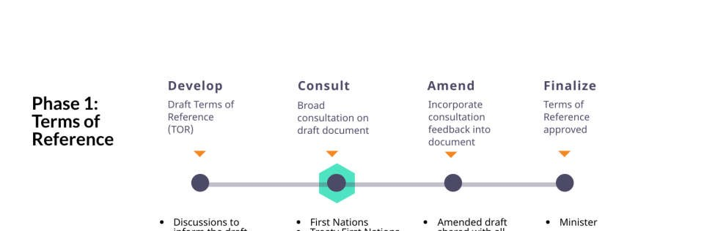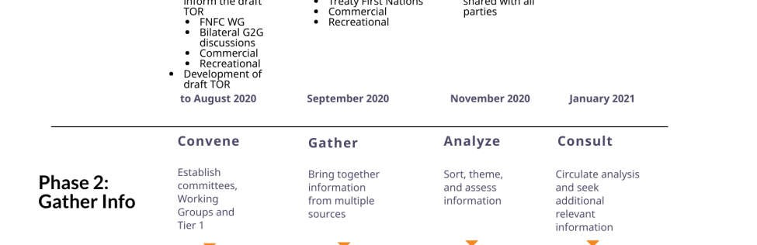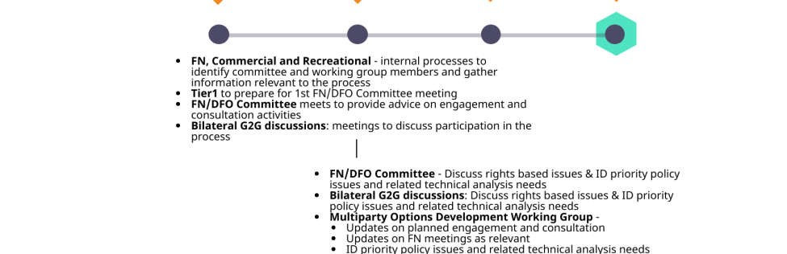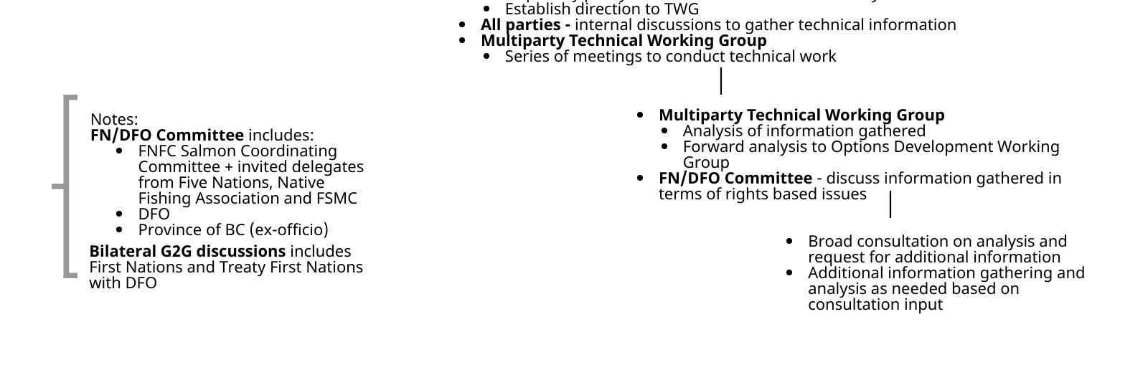
DRAFT SAP Updated Terms of Reference – September 29, 2020 15

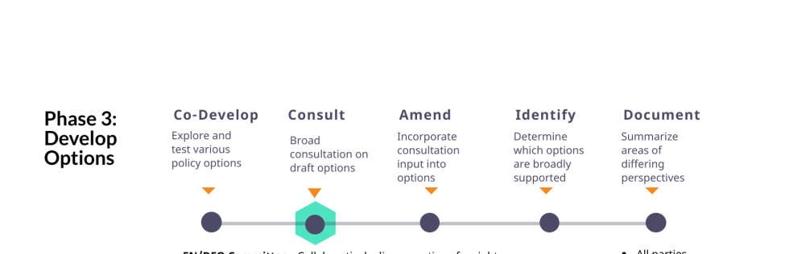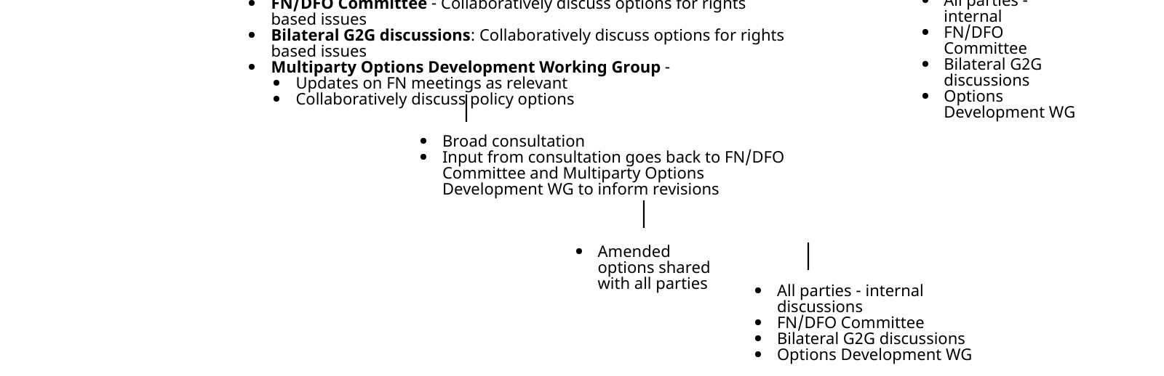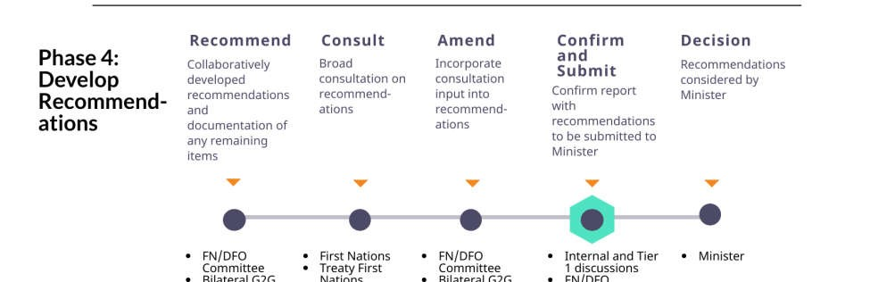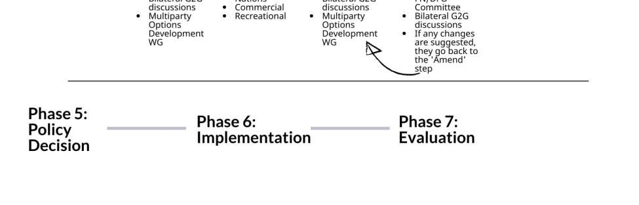

H. Roles and Responsibilities

- Fisheries and Oceans Canada
  - Represent the Department’s perspective and commitments
  - Maintain internal communication between various, relevant DFO branches and processes
  - Identify a team that will consistently attend meetings
  - Adhere to the Terms of Reference
  - Resource the process in a cost-effective way, to an extent that is feasible
  - Contract a facilitator and/ or other specialists, as required and in consultation with First Nations
  - Maintain a website as a platform for ongoing communication throughout the process

- Five Nations (Ahousaht, Ehattesaht/Chinehkint, Hesquiaht, Tla-o-qui-aht,
Mowachaht/Muchalaht), First Nations, First Nations Fisheries Council and other First
Nations organizations
  - Identify First Nations delegates who will consistently attend meetings
  - Respond to correspondence between meetings
  - Adhere to the Terms of Reference
  - Communicate with constituents to report out on the process and bring their interests forward
  - Ensure descriptions of the process or draft policy recommendations are as accurate as possible (e.g. mutually defined) before communications are sent to constituents
  - Seek support for the draft policy recommendations

- CSAB and SFAB
  - Identify representatives who will consistently attend meetings
  - Respond to correspondence between meetings
  - Adhere to the Terms of Reference
  - Communicate with constituents to report out on the process and bring their interests forward
  - Ensure descriptions of the process or draft policy recommendations are as accurate as possible (e.g. mutually defined) before communications are sent to constituents
  - Seek support for the draft policy recommendations

- Facilitators
  - Provide impartial management of the process so participants can focus on substantive issues
  - Design sessions in a way that all participants can contribute to their fullest, discussions are generative, options can emerge, and issues are brought to closure
  - Work with participants to develop session agendas
DRAFT SAP Updated Terms of Reference – September 29, 2020 17

  - Ensure the Terms of Reference and other group agreements are adhered to
  - Develop session summaries and milestone documents
  - Contribute to information accessibility and management by establishing and maintaining collective and individual group Dropboxes.

All participants agree to avoid participation in activities that may undermine commitments that they have made to the process.

I. Consensus Recommendations and Decision Making

- Consensus Recommendations
  - Participants will strive to develop consensus policy recommendations.
Consensus policy recommendations will be circulated to individual BC First Nations for consultation and to the CSAB and SFAB for consideration before they are sent to the Minister of Fisheries, Oceans and the Canadian Coast Guard’s (the Minister) for consideration.
  - DFO will consult on these policy recommendations, and the results of these consultations will be presented to BC First Nations, the FN-DFO Committee, and the Options Development Working Group for discussion and potential revision.
  - Any agreements reached during the development of recommendations will be considered tentative pending consensus on the total package of recommendations to be submitted for the Minister’s consideration, unless participants explicitly agree otherwise on a specific item.
  - If a party wishes to revisit an item for which consensus had previously been achieved, the onus will be on that party to bring the issue to the facilitators at the earliest opportunity and to explain the need for revisiting the item.
  - If the parties reach a consensus that resolves most but not all of the issues that are being addressed, the parties may agree on a statement describing the areas of disagreement, any lack of information or data that prevents such agreement and, where possible, a process for resolving agreement on such issues.
  - If a party withholds agreement on an issue, that party will explain how the proposed agreement fails to meet their interests. The party withholding agreement will have the opportunity to propose alternatives so the other groups can consider how all interests may be met.
  - If agreement is still not reached:
i. the parties may consider engaging a mediator for issue resolution
(see below), or
ii. Recommendations will be provided to the Minister that accurately reflect participants’ different perspectives.
  - The FN-DFO Committee will prepare a report to the Minister setting out the final recommendations, which will be attached to the decision note to the Minister;

i. Parties will not directly present the Minister with recommendations or submissions that have not been previously presented to or shared with the Options Development Working Group and the FN-DFO Committee.
j. Recommendations being advanced to the Minister must come from the FN-DFO Committee. The Minister will not consider recommendations outside of the FN-DFO Committee process.

- Final Decision Making
  - Recommendations will be provided to the Minister in a report from the FN- DFO Committee for consideration. DFO will prepare a formal decision note to accompany the group’s recommendations report. The responsibility for the final decision resides with the Minister. The Department will provide a written rationale for the decision made, including how the decision accords with aboriginal rights and interests and Canada’s legal obligations to First Nations.

J. Issue Resolution

In the event that the parties cannot come to a consensus on policy recommendations, they may jointly choose to engage the assistance of a mutually acceptable party trained in alternative dispute resolution (i.e. negotiation or mediation). The parties will discuss with DFO the possibility of DFO resourcing the issue resolution process from the resources available to support the whole SAP review process, or through other resources. Should the parties fail to reach consensus during dispute resolution, FN-DFO Committee will move forward with developing policy options that reflect the areas of contention but put forward a clear recommendation. DFO will consult on this recommended option before ultimately seeking the Minister’s approval.

K. Deliverables

Two primary deliverables will be produced through the process:
- Recommendations in a report from the FN-DFO Committee for the Minister’s consideration on a renewed Salmon Allocation Policy for BC.
- Summary document of related issues (not within the direct scope of SAP) and suggested processes or venues for addressing these issues where possible.

L. Resourcing

DFO will identify resources to support the SAP review process in a cost-effective way. DFO will work to find mechanisms to flow funding to First Nations (nations, aggregates or organizations), CSAB, and SFAB to assist these groups’ participation in the process. These groups will be invited to submit proposals to DFO for the request of funds at key points throughout the review process.

Parties will also bring to each other’s attention other possible sources of support.

Appendix A: Acronyms and Abbreviations

AAROM | Aboriginal Aquatic Resource and Oceans Management
ATK | Aboriginal Traditional Knowledge
CSAB | Commercial Salmon Advisory Board
DFO | Fisheries and Oceans Canada
FNFC | First Nations Fisheries Council
FSC | Food, Social and Ceremonial
FSMC | Fraser Salmon Management Council
G2G | Government to Government
IFMP | Integrated Fisheries Management Plan
SFAB | Sport Fishing Advisory Board
SAP | Salmon Allocation Policy
TAC | Total Allowable Catch
UFAWU | United Fishermen and Allied Workers’ Union
UNDRIP | United Nations Declaration on the Rights of Indigenous Peoples

Appendix B: Definitions

- Bycatch
● The inadvertent harvest of different species. Bycatch includes retained and nonretained catch.

- Consensus
● While unanimity will be sought, consensus does not require that everyone be in complete agreement. Instead, moving forward in the absence of unanimity is acceptable when:
○ The direction put forward goes as far as possible towards meeting the interests of all parties;
○ all are willing to accept the direction put forward; and
○ no one feels that his/her position on the matter was misunderstood or not given a proper hearing.

- Conservation
● The protection, maintenance, and rehabilitation of genetic diversity, species, and ecosystems to sustain biodiversity and the continuance of evolutionary and natural production processes.²⁰

- Engagement
● A broad term to describe all types of involvement or participation in the SAP process, inclusive of:
○ Government-to-government (G2G) engagement between DFO and First Nations, based on constitutional requirements in respect of Aboriginal and Treaty rights under s.35 of the Constitution Act, 1982, Canada’s commitment to implement UNDRIP, and reconciliation commitments including the Principles Respecting the Government of Canada’s
Relationship with Indigenous Peoples.
○ Collaboration with commercial and recreational sectors
○ Consultation with public
○ Government-to-government engagement between DFO and the Province of British Columbia

- Five Nations
● Ahousaht, Ehattesaht/Chinehkint, Hesquiaht, Tla-o-qui-aht, Mowachaht/Muchalaht who have an Aboriginal right to fish and sell all species (except geoduck) within their territories as recognized by the BC Supreme Court (Ahousaht Indian Band and Nation et al v. Canada).

- Incidental Harvest
• The inadvertent harvest of stocks of concern within the same salmon species (e.g. Cultus Lake Sockeye when harvesting Summer Run Sockeye).

- Incidental Mortality
• Fishing-related incidental mortality (FRIM) includes all mortality associated with fishing activities, beyond the mortality accounted for in retained catch. FRIM includes estimates of mortality rates for fish that encounter fishing gear but are not captured (e.g. escape mortality), that are dead upon or die during capture (e.g. on-board mortality), or that die after release (e.g. post-release mortality).

- Precautionary Approach
    - In general, the precautionary approach in fisheries management is about being cautious when scientific information is uncertain, unreliable or inadequate and not using the absence of adequate scientific information as a reason to postpone or fail to take action to avoid serious harm to the resource.

Applying the precautionary approach to fisheries management decisions entails establishing a harvest strategy that:
    - identifies three stock status zones – healthy, cautious, and critical – according to upper stock and limit reference points;
    - sets the removal rate at which fish may be harvested within each stock status zone;
    - adjusts the removal rate according to fish stock status variations (i.e., spawning stock biomass or another index/metric relevant to population productivity), based on pre-agreed decision rules.
Further, there are five principles of precaution:
    - The application of the precautionary approach is a legitimate and distinctive decision-making approach within a risk management framework.
    - Decisions should be guided by society’s chosen level of risk.
    - To the extent to which information is available, application of the precautionary approach should be based on sound scientific information.
    - Mechanisms for re-evaluation and transparency should exist.
    - A high degree of transparency, clear accountability, and meaningful public involvement are appropriate.

Terms that will require further definition during the SAP review process include access, allocation, and priority.

A copy of the 1999 Policy can be found in the Related Materials section at https://www.pac.dfompo.gc.ca/consultation/smon/sap-prs/index-eng.html DRAFT SAP Updated Terms of Reference – September 29, 2020 1
Treaties and court cases are the vehicles through which First Nations’ rights-based fisheries are recognized. Once recognized, the SAP must clearly outline how these fisheries receive priority of allocation.
Intra-sectoral allocation is defined as sharing arrangements expressed as a percentage allocation or quantum within a sector; for example, the commercial salmon allocation implementation plan identifies how commercial salmon allocations are divided up among the commercial fleets, species and fishing areas in a given year.
See “A fishery decision-making framework incorporating the precautionary approach”, DFO, 2009: https://www.dfo-mpo.gc.ca/reports-rapports/regs/sff-cpd/precaution-eng.htm
Copies of these policies can be found at: http://www.dfo-mpo.gc.ca/reports-rapports/regs/policiespolitiques-eng.htm
Principles respecting the Government of Canada’s relationship with Indigenous Peoples. Department of Justice (2018). Retrieved from https://www.justice.gc.ca/eng/csj-sjc/principles-principes.html
Principles respecting the Government of Canada’s relationship with Indigenous peoples. Department of Justice (2018). Retrieved from https://www.justice.gc.ca/eng/csj-sjc/principles-principes.html ¹⁰ Canada’s Policy for the Conservation of Wild Salmon https://www.pac.dfo-mpo.gc.ca/fm-gp/salmonsaumon/wsp-pss/policy-politique/index-eng.html
Draft Terms of Reference for the Integrated Oceans Advisory Committee (Feb. 15, 2011 version). PNCIMA Initiative.
http://www.businessdictionary.com/definition/accountability.html
https://www.walkthetalk.com/media/sneak_a_peek/lookinside/winning_with_accountability_01.pdf ¹⁴ http://higherstudy.org/reciprocal-accountability-theory/
http://www.shankerinstitute.org/resource/bridging-gap-between-standards-and-achievement
The Ministerial decision note will be confidential and will not be reviewed by the committee.
Adapted from the Integrated Oceans Advisory Committee
Salmon IFMP and Guidance on Implementation of the Policy on Managing Bycatch (2013) http://www.dfo-mpo.gc.ca/reports-rapports/regs/sff-cpd/bycatch-guide-prise-accesseng.htm#toc_annex_1
A Short Guide to Consensus Building.http://web.mit.edu/publicdisputes/practice/cbh_ch1.html ²⁰ Canada’s Policy for the Conservation of Wild Pacific Salmon. Fisheries and Oceans Canada (2005).
Principles respecting the Government of Canada's relationship with Indigenous peoples. https://www.justice.gc.ca/eng/csj-sjc/principles-principes.html
Salmon IFMP
As defined in Canadian Science Advisory Secretariat Science Advisory Report 2016/049 Review and Evaluation of Fishing-Related Incidental Mortality for Pacific Salmon: https://waves-vagues.dfompo.gc.ca/Library/40569020.pdf
A Fishery Decision-Making Framework Incorporating the Precautionary Approach. Fisheries and Oceans Canada (2009).
First Nations’ perspectives into the level of risk must be taken into account.
A Framework for the Application of Precaution in Science-based Decision Making About Risk. Canada, Privy Council Office (2003).

